Contacts Web Application

# Quick Start Guide

Version 1.0

2019/12/11

Document Revision History

| Version Number | Date | Author/Owner | Description of Change |
| --- | --- | --- | --- |
| 1.0 | 2019/12/11 | Romesh Jayawardene | Initial version |
|  |  |  |  |
|  |  |  |  |
|  |  |  |  |
|  |  |  |  |
|  |  |  |  |
|  |  |  |  |
|  |  |  |  |
|  |  |  |  |
|  |  |  |  |
|  |  |  |  |

Table of Contents

1.1 Introduction 4

1.2 Adding a new contact 4

1.3 Editing an existing contact 6

1.4 Marking a contact as Favorite 6

1.5 Responsive Design 8

1.6 Cross-browser compatibility 9

### Introduction

**Contacts** is a simple web application to save and display personal contacts. Each contact consists of a Name, Email and an optional Phone Number.

There are 3 main pages in the application.

* Contacts page: displays a list of contacts
* Favorites page: displays a list of contacts marked as favorite
* Add/Edit contact page: allows the user to add a new contact or edit an existing contact.

The contacts are stored in the local cache of the web browser. Clearing the browser cache will clear the contacts.

Below are identified some of the basic user flows:

### Adding a new contact

The first time the application is loaded, the user will be presented with the following interface:

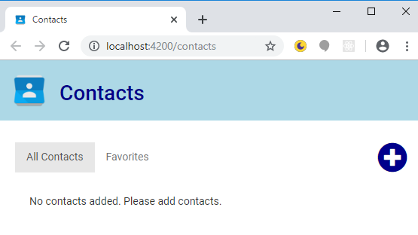

Clicking on the plus icon on the right will take the user to the Add contact page:

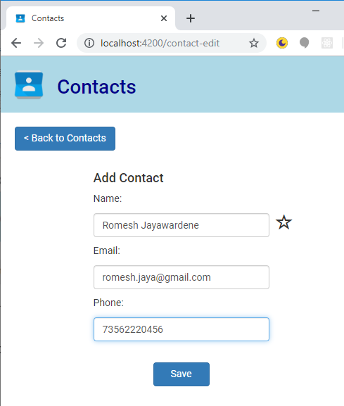

Here the user is prompted to add a name, email address and an optional phone number. Clicking Save will save this data and bring the user back to the Contacts screen, which will now display the saved contact:

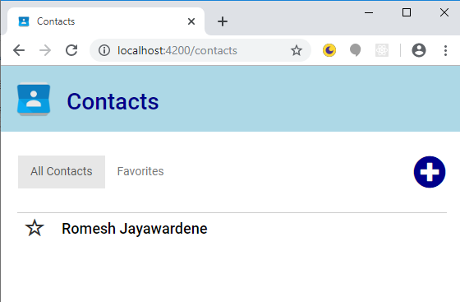

### Editing an existing contact

Clicking on an existing contact will take the user to the Edit contact screen:

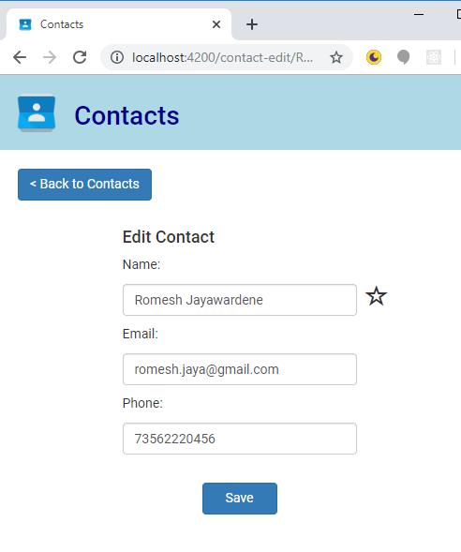

Here the user can make any changes required and press Save to save the changes.

### Marking a contact as Favorite

When adding/editing a contact, it can be marked as favorite by clicking on the star icon to the right of the name as shown below:

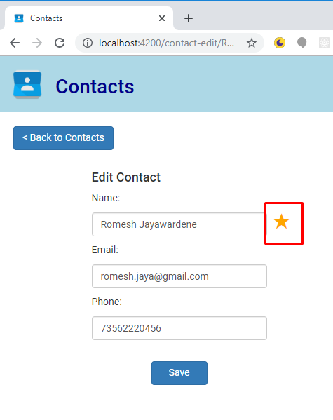

Contacts can also be set or unset as favorites in the contacts page, by clicking on the star icon of the contact:

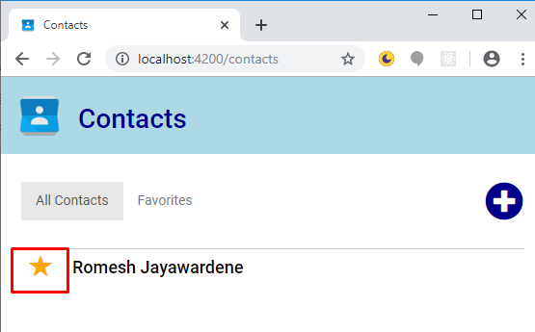

The contacts marked as favorite will now show up under the Favorites page:

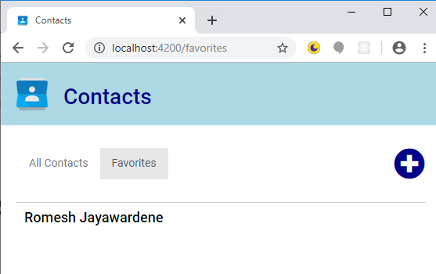

### Responsive Design

The application has been designed to fit on both desktop and mobile screens. The following shows the desktop version of the contacts page, showing all name, email and phone number:

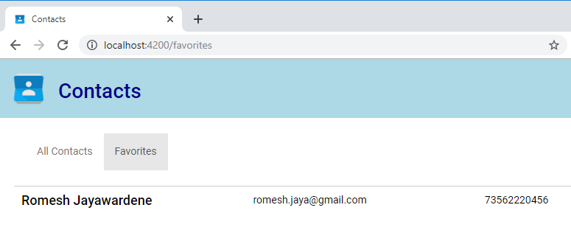

In a smaller screen size, only name and email are displayed:

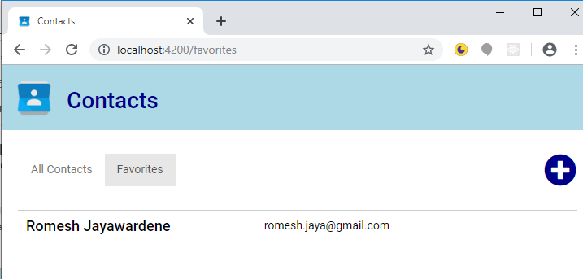

In mobile-sized screens, only the name is displayed:

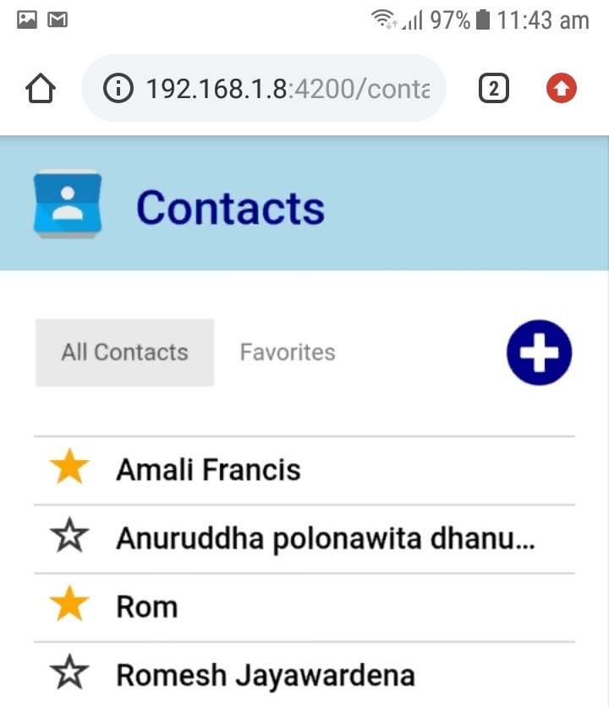

### Cross-browser compatibility

This app has been tested in Chrome v78, Firefox v68 and Microsoft Edge v44.